ĐỀ CƯƠNG ÔN THI LUYỆN ÂM TIẾNG ANH

Câu 1. Which underlined part is pronounced differently?

- A. proved | B.supposed | C. developed | D. followed
- A. needed | B. wanted | C. organized | D. decided
- A. trained | B.impressed | C.proved | D. performed
- A. organize | B. spirit | C. title | D. surprise

Answers:

1. C | 2. C | 3. B | 4. | 5. B

Câu 2. Which underlined part is pronounced differently?

- A. developments | B. facilities | C.stops | D. books
- A. festivals | B. badmintons | C. participants | D. plays
- A. laughs | B. books | C. competitors | D. stops
- A. impresses | B. spirits | C. events | D. wants

Answers:

1. B | 2. | 3. C | 4. C | 5. A

Câu 3. Fill in the blanks with appropriate terms.
- Phonetics is the study of human sounds in general without reference to their systemic role in a specific language. Phonetics is divided into three types according to the (1)_______(articulatory), transmission (acoustic) and perception (auditive) of sounds.
- Sounds can be divided into (2)___________. Consonants can be characterized according to place, manner of articulation, and voice (voiceless or voiced)…
3...........
Answers:
1. production | 2. consonants and vowels | 3.

Câu 4.What is phoneme? (1.5 pts)

(Phoneme is the smallest unit of the sounds of a particular language....)

Câu 5. What is Received Pronunciation?(1.5 pts)

(Received Pronunciation is the standard pronunciation of British English.....)

Câu 6. Complete this diagram.
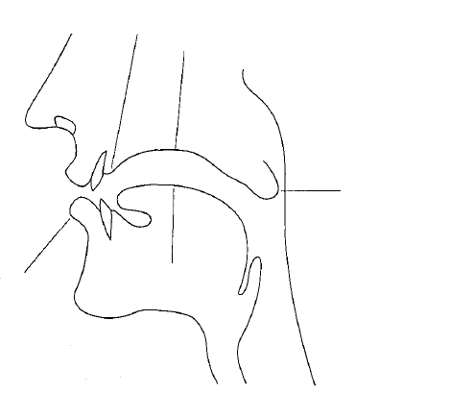
1. ……
3. ……
4……
5. …..
Answers:

1. (lower) lip |  | 3. palate | 4. uvula | 5. tongue

